# Heartrate Sensor Summary

## Introduction

The Wahoo Heartrate Sensor is one of the sensors used in the Smart Bike project to capture the heartrate of the user. This report will briefly detail how the code works, examples of the expected payload and how this sensor fits into the architecture of the Smart Bike project as a whole.

Wahoo Heartrate Sensor used for the Smart Bike project:  
<https://au.wahoofitness.com/devices/heart-rate-monitors/tickr-buy>

## Code

The heartrate sensor that we are using requires two scripts to operate as intended which includes ‘mqtt_client.py’, and ‘heartrate.py’. The ‘mqtt_client.py’ script includes a number of functionalities which enable us to publish to and subscribe from MQTT topics in HiveMQ Cloud. Some of these functionalities include enabling Transport Layer Security (TLS), setting username & password, connecting to HiveMQ Cloud and also publishing & subscribing MQTT data. The ‘heartrate.py’ script is responsible for connecting to the heartrate sensor and uses the functionalities provided by the ‘mqtt_client.py’ script to publish the sensor data collected to the HiveMQ MQTT Broker. The script also makes use of Generic Attribute Profile (GATT) which establishes how Bluetooth Low Energy (BLE) devices communicate with each other. There is another script within the folder called ‘subscriber.py’ which is used for debugging purposes and basically subscribes to the MQTT heartrate topic and prints everything it sees to the console.

## Example Payloads

A table has been provided below which showcases examples of the expected payload that would be published to the MQTT broker. Heartrate indicates the speed of the user’s heart and is measured in beats per minute and has a range of 0 to 220.

|  |  |  |
| --- | --- | --- |
| **Topic** | **Payload** | **Description** |
| Bike/00001/heartrate | Ts: 11662625808, heartrate: 105 | The heartrate of the user on Bike One is 105 beats per minute |
| Bike/00001/heartrate | Ts: 11662625808, heartrate: 79 | The heartrate of the user on Bike One is 79 beats per minute |
| Bike/00002/heartrate | Ts: 11662625808, heartrate: 152 | The heartrate of the user on Bike Two is 152 beats per minute |

## Architecture

Figure 1 below showcases the architecture used in the Smart Bike project. In the top-left corner, the heartrate sensor which is named ‘Wahoo TICKR Heart Rate Sensor’ can be found. The heartrate sensor publishes data to the HiveMQ MQTT Broker before being stored in a database. Along its path is several devices which it communicates with such as the Raspberry Pi device seen next to the sensor in figure 1. The data stored in the data base can then be used in software such as video games, mobile applications and the web which is also indicated in the bottom-left of figure 1 below.

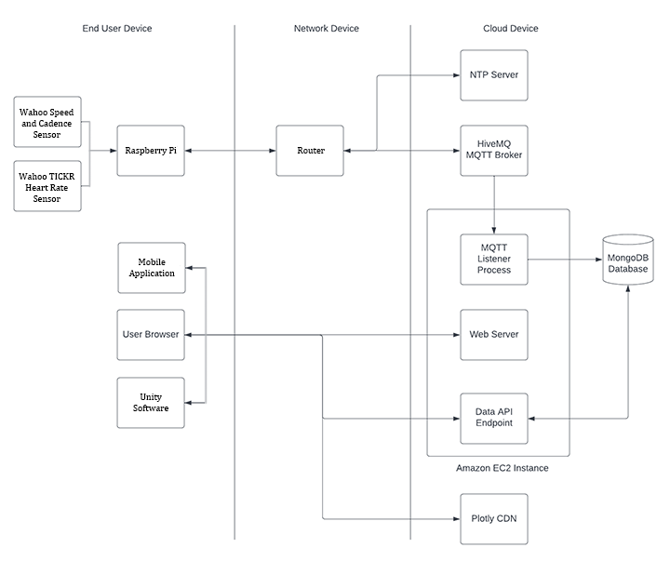

Figure - Suitable Architecture based on the architecture provided by Adrian Grigo and modified by myself